SFTR Good to Trade (GTT) User Application

Contents

Background 1

In-Scope Check 1

GTT Check 2

The Challenge 3

Suggested System Components 3

Challenge Judging Points: 4

Provided Data 4

Trade Data File (gtt_trade_data.json) 4

GTT Data File (gtt_api_data.json) 5

Example UIs 5

Example of a Query Interface 6

Example of a Query-by-Date Results 6

Example of a Query-by-Trade-ID Result 6

Example of a Query-by-Client-ID Result 7

# Background

Good to Trade (GTT) is a post-trade review check. All trades that have been executed on a prior business day are checked to see if they are in scope for a GTT check. Any in-scope trades that fails a GTT check (hence not Good to Trade) must be reported to the Customer Support Team for follow-up. The Federal National Bank (FNB) wants you to create a user application for the Customer Support Team to meet this need.

## In-Scope Check

Each trade has a ‘reporting counterparty’ on it. The ‘reporting counterparty’ is one of the Federal National Bank (FNB) subsidiary legal entities and its role is to report the trade to the regulator in its jurisdiction. There is usually an individual subsidiary for each jurisdiction (e.g. for each country) however for this project we shall assume that we only have 3 entities: FNB-UK, FNB-EU, FNB-SG. Only trades of which the ‘reporting counterparty’ is FNB-UK and FNB-EU are in scope and be required a GTT check.

The type of trades we will be checking are Securities Financing Transaction Regulation (SFTR) trades. SFTR is an EU transaction reporting regime and it aims to increase transparency of banking activities for securities lending, repurchase transactions and prime brokerage margin loans.

| **SFTR Product** | **Definition** |
| --- | --- |
| REPURCHASE | A transaction governed by an agreement by which a client transfers securities where a guarantee is issued by a recognised exchange which holds the rights to the securities and the agreement does not allow a client to transfer or pledge a particular security to more than one client at a time, subject to a commitment to repurchase them at a specified price on a future date specified. |
| BUY_BACK | A transaction by which a client buys securities and agrees to sell back securities of the same description at a specified price on a future date |
| SECURITIES_LENDING | A transaction by which a counterparty transfers securities subject to a commitment that the borrower will return equivalent securities on a future date or when requested to do so by the transferor. |
| MARGIN_LENDING | A transaction in which a prime broker extends credit in connection with the trading of securities, but not including other loans that are secured by collateral in the form of securities. |

A trade is in scope to perform a GTT check ONLY if the information on the trade meets all the criteria listed below. GTT check should not be performed on trades that don’t meet this criteria.

* Regulation = ‘SFT_REPORTING’
* Reporting Side = ‘FIRM’
* Jurisdiction = ‘UK or ‘EU’
* Security Types = ‘SECURITIES_LENDING’, ‘REPURCHASE’, ‘MARGIN_LENDING’, ‘BUY_BACK’
* Reporting Counterparty = ‘FNB-UK’ or ‘FNB-EU’

## GTT Check

The GTT Check examines the ‘counterparty/client’ and the ‘reporting counterparty/FNB Entity’ from each in-scope trade and makes an API call to GTT service (with these 2 parameters).

The GTT service should check against the internal data (provided as gtt_api_data.json) for the status of the 3 required documents that the client must have filed with the FNB entity. The 3 documents are ‘AML/KYC’, ‘LEI’ and ‘Reporting Consent’. More information about each these documents are in the next table.

| **Document Type** | **Description** |
| --- | --- |
| AML/KYC | A set of questionnaire answered for the client, for purpose of “Anti-Money Laundering” and “Know Your Client” processes. |
| LEI | A document stating the registered “Legal Entity Identifier” of the client. |
| Reporting Consent | A consent agreement provided by counterparty/client to enable the necessary reporting based on the client’s data to be performed. |

Each document is filed for the client against a FNB legal entity. Availability of a particular document is indicated by a RED or a GREEN status. RED status indicates that the particular document for the client/reporting counterparty combination is not available or has expired. During GTT check for a trade, if one of the 3 documents of the client against the reporting counterparty is of status RED then the GTT requirement of this trade in SFTR products has failed, and hence the trade should be flagged to the Customer Support Team.

If all the 3 documents for the client against the reporting counterparty have a ‘GREEN’ status, then the trade is considered to have happened under satisfactory good to trade condition and nothing needs to be done.

# The Challenge

Develop a system of ‘Good to trade’ applications to support the SFTR asset class.

The system shall have a UI that enables the Customer Support Team to perform these 3 queries:

* Query by ‘Date’:
  + Display all clients of which their trades fail GTT for the given date.
  + For each client, display:
    - The incomplete documents on the FNB entity
    - The trades that failed GTT.
  + If all clients are GTT for all trades on the given date – display this message to the user.
* Query by ‘Trade ID’:
  + Display why the trade is not GTT. Display:
    - The client
    - The FNB entity
    - The incomplete documents
  + If the trade is GTT – display this message to the user.
* Query a ‘Client ID’:
  + Display all FNB entities where the client is not setup correctly. For each FNB entity, display:
    - the incomplete documents
    - the trades done by the client
  + If the client is GTT for all in scope FNB entities – report this message to the user.

## Suggested System Components

This is an example solution to support the 3 scenarios. It consists of these application components:

1. File Parser:
   * Read the Trade data supplied (trades.txt)
   * Store the trade data into a database (select which fields from the trade you will require to store)
2. GTT Backend Application(s):
   * Provide Rest API functions that will be invoked from the frontend for the 3 user queries
   * Provide GTT service that will be called to get the GTT status for a given counterparty/reporting counterparty combination.
   * Decide how you will design and implement this functionality.
3. Front End Application: UI for the User

* An example of a web-based UI is being used in the Examples section.
* Other examples:
  + Logs / Email summary / Mobile App
  + Explain why you chose your solution (advantages and disadvantages)

The components can be built using a variety of technology suitable for the problem at hand.

## Challenge Judging Points:

* Backend Design, architecture, scalability, maintainability and test cases (20 pts)
* Development of the essential components (Parser, DB, API, Front End) (20 pts)
* Correctness of results (20 pts)
* Front End Design and Function (20 pts)
* Presentation on thinking process, design considerations, solutions and challenges faced (20 pts)

Points to consider:

* You are free to implement using any framework of choice.
* Some suggested technology stacks are:
  + Python/Java/Scala
  + Flask/Django/Tomcat/Jetty/others
  + SQLite3/MySQL/other db
* Your application code should show clear logic.
* Determine what is useful to log and the logging format.
* Attention to quality of code may be important. For example, add error handling throughout the application for frequent issues such as:
  + Connecting to the database fails
  + Error in input files (e.g. regulation is missing on some trades)
* Design an intuitive UI for the user

# Provided Data

## Trade Data File (gtt_trade_data.json)

Each line in the file is an individual trade. Each trade contains the following information:

* Counterparty (client)
* Reporting Counterparty (FNB entity)
* Date of trade
* ID of trade (unique across all dates/clients)
* Reporting side
* Regulation in-scope
* Jurisdiction (a geographic region)
* Trade type as defined under SFTR

Example:

{"regulatoryReportingDetails":

{"counterpartyID": "Sumitomo13", "reportingCounterpartyID": "FNB-EU"},

"date": "20210607",

"tradeID": "P98ICK2EYR-10172",

"reportingSide": "FIRM",

"regulation": "SFT_REPORTING",

"jurisdiction": "UK",

"securitiesFinancingTransactionType": "BUY_BACK"}

## GTT Data File (gtt_api_data.json)

Each line in the file represents the documentation Information stored for a client against each FNB legal entity. As an example:

{"Cargill16": [

{"entityId": "FNB-UK", "documentId": "LEI", "status": "GREEN"},

{"entityId": "FNB-UK", "documentId": "REPORTING_CONSENT", "status": "GREEN"},

{"entityId": "FNB-UK", "documentId": "AML_KYC", "status": "GREEN"},

{"entityId": "FNB-EU", "documentId": "LEI", "status": "GREEN"},

{"entityId": "FNB-EU", "documentId": "REPORTING_CONSENT", "status": "GREEN"},

{"entityId": "FNB-EU", "documentId": "AML_KYC", "status": "RED"}]}

The information in the example is:

* The client ID is “Cargill16”
* This client is set up with FNB-UK and FNB-EU
* All 3 documents of Cargill16 against FNB-UK are green.
* LEI and REPORTING_CONSENT document of Cargill16 against FNB-EU are green while its AML_KYC against the same legal entity is RED.

# Example UIs

A very simple example solution is presented below to give you a basic starting point. Please use your own ideas and format to make it unique, intuitive, user friendly and robust.

The following screenshots are just of an example. You should carefully consider UX when designing your UI.

## Example of a Query Interface

The user enters criteria details in one (and only one) of the fields and submit this form to start the query.

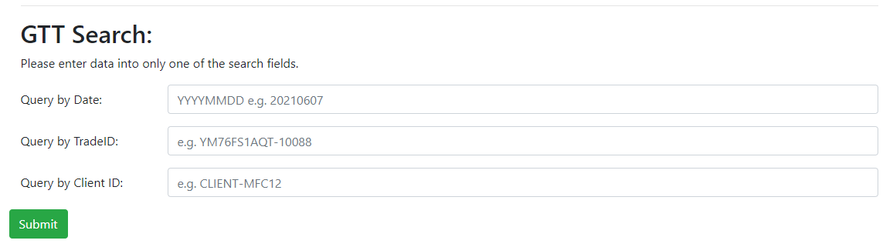

## Example of a Query-by-Date Results

Displays the clients, the docs that are not GREEN and the trades which fail GTT.

|  |
| --- |
|  |

## Example of a Query-by-Trade-ID Result

If the trade fails GTT, displays the client and reporting counterparty of the trade and documents missing.

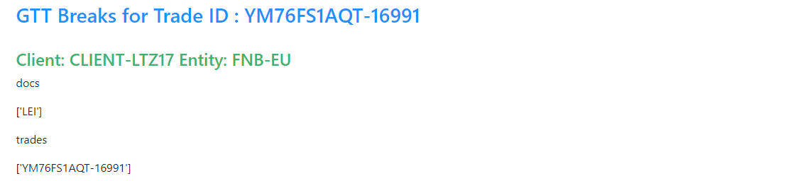

## Example of a Query-by-Client-ID Result

Displays the reporting counterparties under which the client has trades failing GTT. Shows the documents which are not GREEN and the trade IDs.

